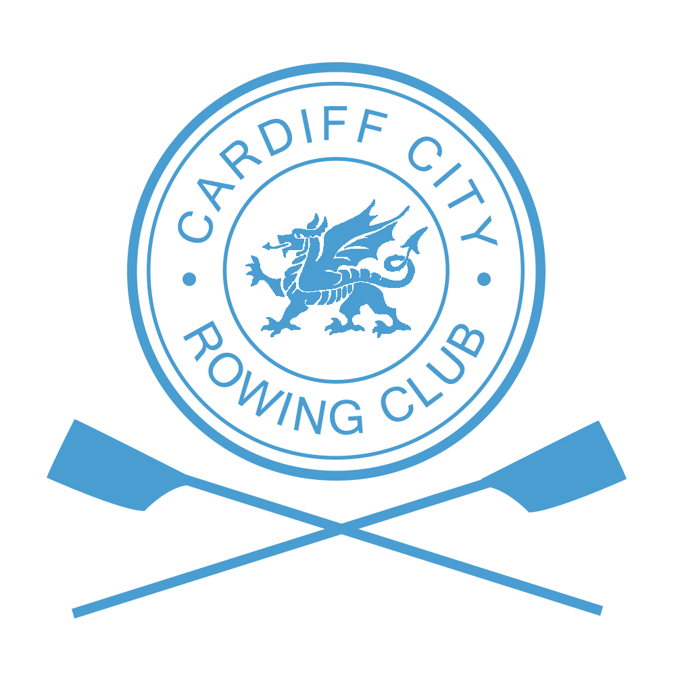

Information for Competitors

Directions
Cardiff City Head of the Taff is based at Channel View Centre, Jim Driscoll Way, Grangetown, Cardiff, CF11 7HB.

Boat trailers and trailer parking
On arrival at Channel View via Jim Driscoll Way, trailer drivers will be directed by parking marshals to their parking area (if there are no marshals available to direct drivers at that moment please park trailers in a safe area and not in the way of public traffic.). Trailers must be parked and boats rigged in the areas designated. Towing vehicles must be parked off site as there will be limited space available at Channel View.

All Boats will launch from the rowing pontoons based at Cardiff Bay Water Activity Centre, Channel View.

Car Parking
Limited on site car parking is allowed, however we cannot guarantee that there will be space to park near trailers/boats. On-street parking is available close to the Centre in Mermaid Quay, Grangetown, IKEA or public parking areas at the nearby Cardiff Bay Retail Park (please be aware of time restrictions) Parking in these areas are only 5-10 minutes walking distance from the centre.

Numbers
Club captains or representatives of clubs should collect numbers for their divisions at registration/ race control which will be based within the Channel view boathouse . Payment of entries should already have been completed prior to picking up numbers and registering boats. Numbers will not be given out if payment has not been received. Issues with payment should be told in advance with regatta secretary.

Briefing and Boating
There will be a short briefing for captains, coxes and steersmen at 0845hrs (Division 1) and 1215hrs (Division 2) outside the main boathouse however this is weather dependen (within the boathouse if raining). Boating will commence immediately after the briefing. Please boat in number order to ensure that boats are set off in order at the start and to allow less confusion during marshalling.
Racing in Division 1 will start promptly at 1000hrs and Division 2 at 1330hrs.

Course map and start plan
The course map and start plan for both divisions has been linked to the Club website. Please follow the link for ‘Marshalling and race plan’ for the course map. Please follow navigation rules which are outlined further on the course map.

Safety launches will be on the river to help any crews during marshalling and racing. The river will be closed during racing between Castle bridge and the PDR bridge, crews must turn before the PDR bridge to avoid other water crafts using the Bay side of the PDR.

First Aid
The Civil Aid Voluntary Rescue Association (CAVRA) will provide first aid cover close to Channel View Leisure Centre pontoon. A first aid vehicle will be located at Channel View. Please contact any member of CAVRA if assistance is required. Members of Cardiff City Rowing Club are also on hand during the day for any assistance required, please speak to Arthur Lovatt for any health and safety concerns.

Changing Facilities
Channel View leisure centre has recently undergone a redevelopment which now allows more space and facilities for people to use as changing rooms, lockers are also available for people to use. (Please ensure you bring a £1!)

Prizes
Medals will be awarded for all events in which three or more crews start either in their designated division or in the case of an event being offered over both categories, fastest boat in that category of the day in which three or more crews start. The organising committee will promote crews to the most suitable category where available unless specific instruction is sent to the Regatta Secretary prior to the final draw being published. Other entries will be ‘time only’.

Refreshments
Members of Cardiff City Rowing Club will be running a catering stand in the boathouse. Homemade food will be sold during the day including a range of savoury and sweets. A range of hot and cold drinks will also be sold on the stand.

Results and Prize Giving
This year the Head Race will be using Row timer as their timing software. To locate results and times please ensure that following racing that you click the link on our website for a link to row timer.
Prize giving will be held at the end of division 2, following the end of racing.

Emergency Contacts
In the event of an emergency, contact the race organizer/regatta secretary, by phone, on 07852579068 or radio.

If the event is cancelled
Cardiff City Rowing Club will do their best to ensure that the event is run on the 27th January, however the head race is weather dependent. Our safety officer will be ensuring that checks are made prior to the event and during the day. If the event is to be cancelled we will notify clubs of this through email and social media. If there are any issues or queries on this then please contact the regatta secretary via email gwenllianj@hotmail.com or phone 07852579068.

Finally, Cardiff City hope you have a good day of racing and hope to see you back in the Autumn Head in October
Thank you for your continued support for the event.

