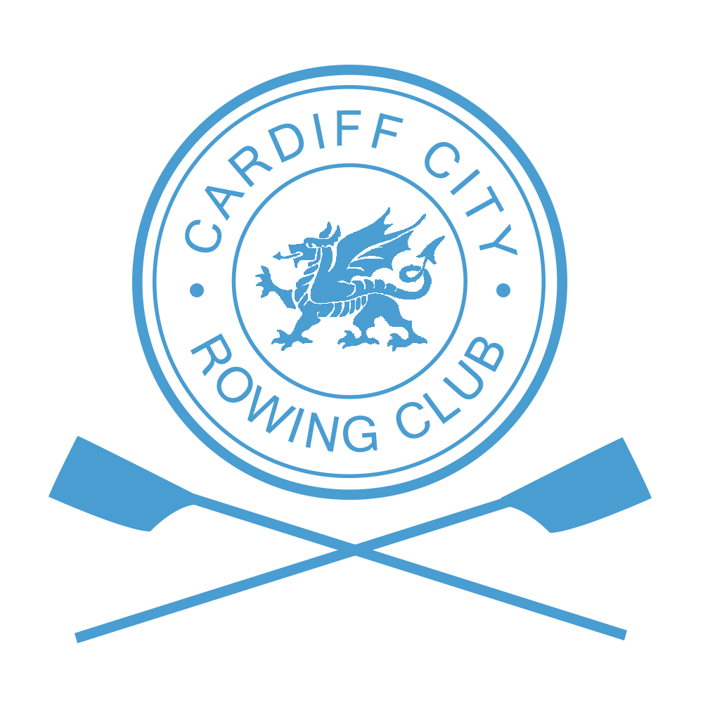
Autumn Head of the Taff 2019
Sunday 13th October 2019

3200m on the River Taff
2200m for Short Course

Racing will be held under the British Rowing Rules of Racing and the management of Cardiff City Rowing Club.

Entry fee £9 per seat (excluding coxes)

Division 1 (10:00 am) and Division 2 (1:30 pm)
Boating in number order

Events are offered for open and women’s crews with mixed crews offered for Masters.
All senior, Masters and J18 events will row the long course
J18 also have option to row short course except for J18 8+
(J18 short course should be entered as J18 B on BROE2)
Beginner events are offered for rowers with less than one year’s rowing experience and will row the short course
(Beginners should be entered as NOVICE with an email sent to regatta secretary notifying of such.)

 | Division 1 (10am) | Division 2 (1.30pm)
Long Course | 8+, 4+, 4-, 4x, 2-, 2x, 1x | 8+, 4+, 4-, 4x, 2-, 2x, 1x
Short Course | 8x+, 4+, 4-, 4x, 4x+, 2-, 2x, 1x | 8x+, 4+, 4-, 4x, 4x+, 2-, 2x, 1x

*Short course should be used for junior categories or for novice (seniors and masters) rowers with less than a years rowing experience. *

Individual medals will be awarded to all contested events with 3 or more entries.
Crews in uncontested events will be moved up in status to the nearest contested event unless a request is made with the entry that the crew does not wish to change status.
.
Results will be taken across the divisions and medals awarded on the overall placing

Entries close on Monday 7th October 2019

Entries must be made via British Rowing Online Entry, any queries or issues following this date please contact the entries secretary, details found below.

Payment must be received prior to event.
Clubs accept liability of payment for all entered crews, including those that subsequently scratch after entries have closed

Further details are available on www.cardiffcityrc.com for any other enquiries please contact:
Regatta Secretary Georgina Wren at wren.georgina@outlook.com or mobile 07930415168

