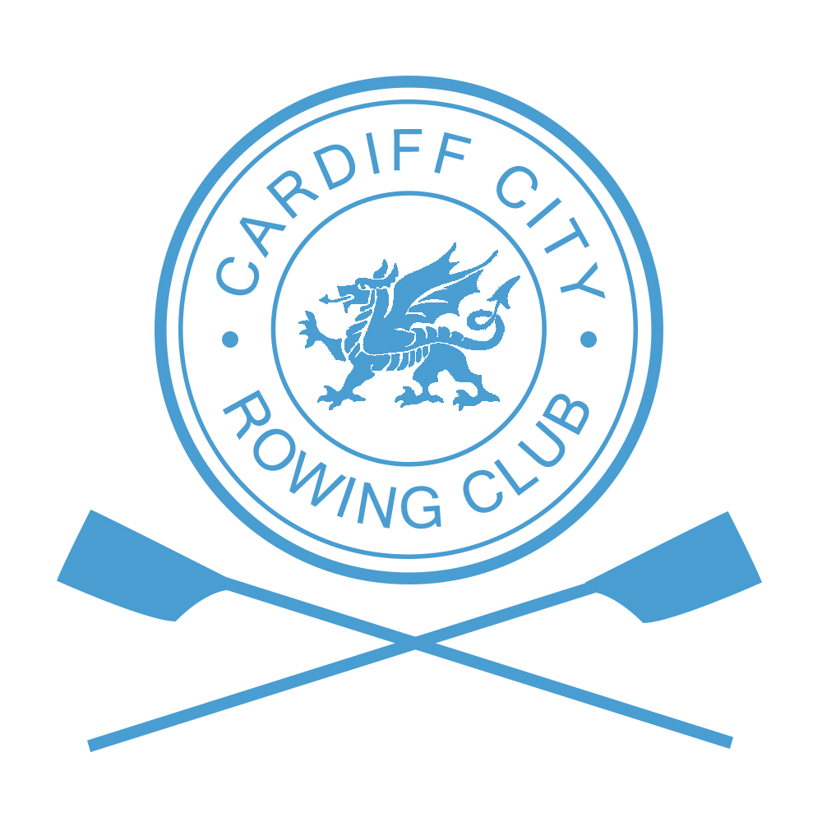

Information for Competitors

Directions
The Head of the Taff is run from Channel View Centre, Jim Driscoll Way, Grangetown, Cardiff, CF11 7HB.

Boat Trailers
On arrival at Channel View trailer drivers will be directed to their parking area. Trailers must be parked and boats rigged in the areas designated. Towing vehicles must be parked off site as there will be limited space available at Channel View.

Car Parking
No on site car parking is allowed. On-street parking is available close to the Centre, in Grangetown or alternatively in the IKEA or public parking areas at the nearby Cardiff Bay Retail Park (please be aware of time restrictions)

Numbers
Club captains only should collect the numbers and instructions and pay outstanding monies at race control located on the ground floor of Channel View Centre. Numbers will be issued to a club when all formalities have been completed.

Briefing and Boating
There will be a short briefing for captains, coxes and steersmen at 0830hrs (Division 1) and 1215hrs (Division 2) outside the ‘Crew Room’. Boating will commence immediately after the briefing.
Racing in Division 1 will start promptly at 1000hrs and Division 2 at 1330hrs.

Changing Facilities
Changing rooms with lockers are available at the Channel View Centre.

Prizes
Medals will be awarded for all events in which three or more crews start either in their designated division or in the case of an event being offered over both categories, fastest boat in that category of the day in which three or more crews start. The organising committee will promote crews to the most suitable category where available unless specific instruction is sent to the Regatta Secretary prior to the final draw being published. Other entries will be ‘time only’.

First Aid
The Civil Aid Voluntary Rescue Association (CAVRA) will provide first aid cover close to Channel View Leisure Centre pontoon. A first aid vehicle will be located at Channel View. Please contact any member of CAVRA if assistance is required.

Refreshments
Rolls, cakes and tea/coffee will be available throughout the day.
Canned and energy drinks will be available from vending machines on the ground floor of the Centre.
A range of meals can be purchased from IKEA, Pizza Hut and outlets in the nearby Cardiff Bay Retail Park.

Results and Prize Giving
Results will be made available as soon as possible after each division and posted on the club website at www.cardiffcityrc.com. Prize giving will take place after the completion of competition in the Crew Room..

Emergency Contacts
In the event of an emergency, contact the race organiser, by phone, on 07403 487255 or radio.

